LPCFC Give to the Max!
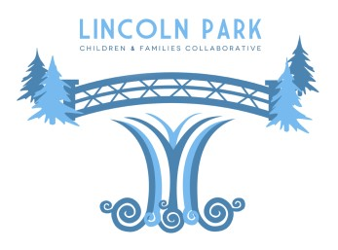
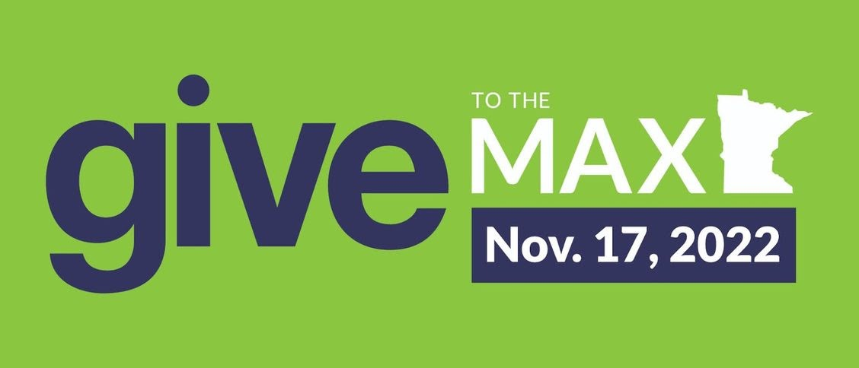
Greetings,
Each year we celebrate our work by participating in Give to the Max, which is a day that people can support our projects by making an online donation on GiveMN.org. Our page can be found at www.givemn.org/organization/Lincoln-Park-Children-And-FamiliesCollaborative. On this page, donors can learn more about our organization, view over 100 pictures of our work, access links to our website, Facebook page, Instagram account, and YouTube channel, as well as make a donation.
Our 2022 Give the Max donation goal is $15,000. We have a donor who donated $1500 and if we raise another $12,000 during Give to the Max (Nov. 1st- Nov. 17th), they will donate another $1500!
Please consider sharing and checking out our page on GiveMN.org and donating on, before or after, November 17, 2022. If November does not work out, donations can be accepted at any time throughout the year on our GiveMN.org page. If online donating is not your thing, we can also accept cash and checks. Checks can be made out to: Lincoln Park Children and Families Collaborative and mailed to: 2424 West 5th Street, Suite 10 and 108, Duluth, MN, 55806.
If you cannot donate at this time or have already reached your donation limit to LPCFC this year, please consider sharing our donation ask with your family members, friends, and colleagues. Donations made on Give to the Max Day (Nov. 17th) through the GiveMN.org page will enter us into a drawing and may help us win additional cash prizes up to $10,000 from GiveMN. If you are on Facebook, please consider sharing our Facebook Fundraiser that we created. It can be found at: www.facebook.com/donate/686525252701436/.
Thank-you and Miigwech!

Please check out our Supporters page on our website to see all the amazing support we receive!
Copyright (C) 2022 Lincoln Park Children and Families Collaborative. All rights reserved.
You are receiving this email because you opted in via our website.
Lincoln Park Children and Families Collaborative
2424 West 5th Street, Suite 10
Duluth, Mn 55806

Add us to your address book
Update Preferences | Unsubscribe

